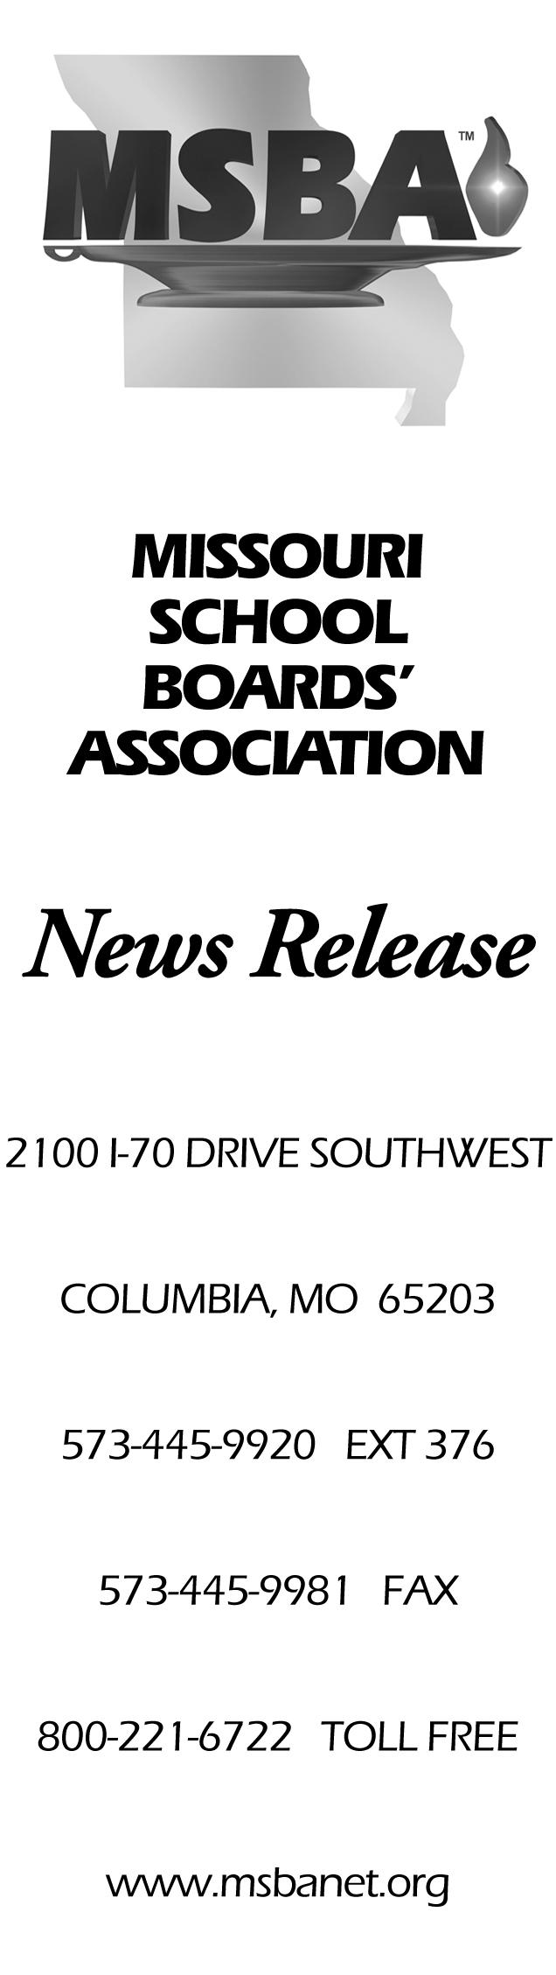 | June 10, 2019  For Immediate Release  Contact: Brent Ghan  573-445-9920, ex. 376  Local school boards receive  Governance Team honor  Thirty-three Missouri school boards have received the Missouri School Boards’ Association’s 2019 Governance Team Award. This prestigious award is based on those school boards’ outstanding commitment to ongoing professional development in areas such as student achievement, school law and finance, board operations and contemporary issues in education. The award also recognizes their commitment to regional and statewide leadership and to active participation in legislative advocacy for public schools and the students they serve.  The honored school boards are Ash Grove R-IV, Bayless, Branson R-IV, Cameron R-I, Cape Girardeau 63, Crawford County R-I, Dunklin R-V, Ferguson-Florissant R-II, Francis Howell R-III, Ft. Zumwalt R-II, Gasconade County R-I, Grain Valley R-V, Hazelwood, Hillsboro R-III, Independence 30, Kirkwood R-VII, Liberty 53, Lindbergh Schools, Malden R-I, Mehlville School District, Montgomery County R-II, Nixa Public Schools, North Kansas City 74, Orchard Farm R-V, Raymore-Peculiar R-II, Raytown C-2, Reeds Spring R-IV, Republic R-III, Rolla 31, Sparta R-III, Ste. Genevieve R-II, Washington, and Webster Groves.  Those school boards met the following criteria:  - All seven school board members in each awarded district have completed the Essential certification from MSBA.  - The district is fully accredited.  - At least two board members in each awarded district have attained the Advanced level of certification from MSBA.  - At least one board member in each awarded district has attained the Master’s level of certification.  - At least a quorum of the board and the superintendent attended the 2018 MSBA Annual Conference and a regional meeting during the past year.  - A representative attended the 2019 MSBA Legislative Forum.  - Each awarded district had representative participation in MSBA’s Delegate Assembly.  The 2019 Governance Team Award winners were recognized on June 8 during the 2019 MSBA’s Leadership Summit in St. Charles.  ##

